DATA MINING – DAY 4
Complete Experiment Documentation
13 Experiments • Datasets • Procedures • Calculations • Results • Graphs • WEKA guidance
Table of Contents
1. Customer Clustering Analysis
2. K-Means Clustering in WEKA
3. Naïve Bayes vs SVM
4. Vegetarian / Non-Vegetarian Count
5. Mobile Phone Sales Scatter Plot
6. FP-Growth Association Rules
7. Diabetes Classification: Decision Tree vs SVM
8. Data Binning and Histogram
9. Decision Tree and Rule-Based Induction
10. Apriori vs FP-Growth
11. Normalization of Strike Rates
12. Car Speed and Time Statistics
13. Apriori and FP-Growth Frequent Itemsets
Documentation note: The uploaded exercise sheet defines the tasks and datasets, but it does not provide actual WEKA/R output screenshots for every experiment. Therefore, software-result figures in this document are explicitly labeled illustrative where applicable; calculations are based on the supplied values. The exercise sheet contains 13 numbered tasks. fileciteturn1file0L40-L42
Experiment 1: Customer Clustering Analysis
Aim: To segment supermarket customers using Customer ID, age, gender, annual income and spending score, and identify customer groups useful for marketing strategy.
Problem Statement: Understand customers who can easily converge as target customers so the data can be given to the marketing team and a suitable strategy can be planned. The source describes segmentation based on Annual Income and Spending Score. fileciteturn1file0L40-L40
Method: K-Means clustering.
- Prepare the customer dataset in CSV format.
- Open the dataset in WEKA Explorer.
- Use Cluster → SimpleKMeans.
- Select the relevant numeric attributes, especially Annual Income and Spending Score.
- Try different values of k and compare the resulting clusters.
- Visualize the clusters using the plot/visualize cluster assignments.
Expected interpretation: Typical segments can be described as low-income/low-spending, low-income/high-spending, high-income/low-spending, high-income/high-spending, and intermediate customers. The exact cluster labels should be assigned after observing the actual cluster centroids.
Result: K-Means can be used to divide customers into meaningful groups based on similarity in income and spending behavior.
Experiment 2: K-Means Clustering in WEKA
Aim: Create the supplied employee dataset in CSV format, perform K-Means clustering in WEKA, change cluster size, and visualize the clusters. The source supplies six records with EmployeeID, Gender, Age, Salary and Credit. fileciteturn1file0L42-L83
EmployeeID | Gender | Age | Salary | Credit
111 | Male | 28 | 150000 | 39
222 | Male | 25 | 150000 | 27
333 | Female | 26 | 160000 | 42
444 | Female | 25 | 160000 | 40
555 | Female | 30 | 170000 | 64
666 | Male | 29 | 200000 | 72
CSV content:
EmployeeID,Gender,Age,Salary,Credit
111,Male,28,150000,39
222,Male,25,150000,27
333,Female,26,160000,42
444,Female,25,160000,40
555,Female,30,170000,64
666,Male,29,200000,72
- WEKA → Explorer → Preprocess → Open the CSV file.
- Go to Cluster → Choose SimpleKMeans.
- Set number of clusters, for example 2, and run the model.
- Repeat with 3, 4 and other cluster sizes requested by the instructor.
- Use Visualize cluster assignments and select Salary/Credit as the plotted attributes.
- Record cluster centroids and assignments in the lab record.
Figure 2.1 – Illustrative dataset visualization (not a WEKA screenshot)
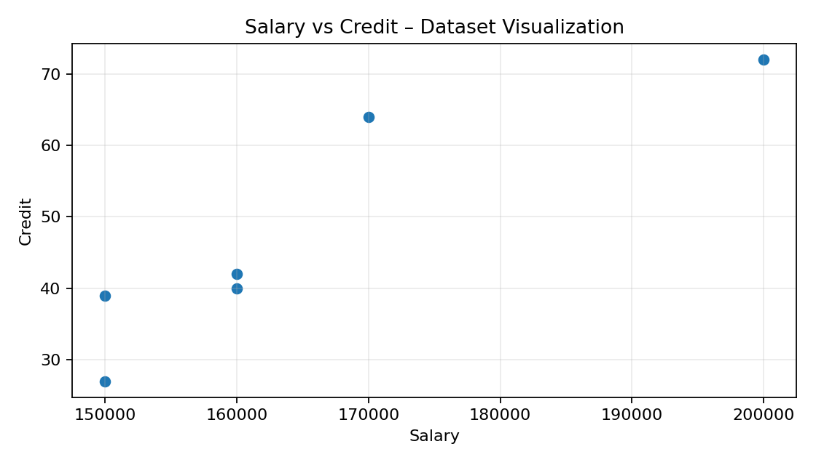
Result: The supplied data show lower credit values around salaries of 150,000–160,000 and higher credit values at 170,000–200,000. Actual K-Means assignments depend on the chosen k and WEKA run.

Experiment 3: Naïve Bayes Classification and SVM Comparison
Aim: Predict categorical data using Naïve Bayes in WEKA and compare it with SVM using classifier summaries and a graph. This is the task specified in the source sheet. fileciteturn1file0L87-L87
- Load a categorical classification dataset in WEKA.
- Preprocess and select the class attribute.
- Classify → NaiveBayes → choose the desired test option.
- Record correctly/incorrectly classified instances, accuracy, precision, recall and F1 where available.
- Repeat with an SVM classifier such as SMO.
- Compare the summary results and plot accuracy.
Metric | Naïve Bayes | SVM
Accuracy | Record WEKA value | Record WEKA value
Precision | Record WEKA value | Record WEKA value
Recall | Record WEKA value | Record WEKA value
F1 | Record WEKA value | Record WEKA value
Result: The better classifier is the one with stronger test performance on the selected dataset. Because the source does not provide a specific dataset or WEKA output, numerical classifier results should be taken from the actual WEKA run.

Experiment 4: Vegetarian and Non-Vegetarian Count
Aim: Count vegetarian and non-vegetarian persons and determine which category has the greater total. The source gives 10 people and their yes/no values. fileciteturn1file0L92-L116
Person | Vegetarian
Gopu | yes
Babu | yes
Baby | yes
Gopal | no
Krishna | yes
Jai | no
Dev | no
Malini | yes
Hema | yes
Anu | yes
Calculation: Vegetarian = 7; Non-vegetarian = 3.
Result: Vegetarian count is greater by 4 persons.

Experiment 5: Mobile Phone Sales Scatter Plot
Aim: Plot the supplied x,y points, where x represents number of mobile phones sold and y represents money. The source provides 10 pairs. fileciteturn1file0L119-L142
x – Phones Sold | y – Money
4 | 12
1 | 5
5 | 13
7 | 19
10 | 31
2 | 7
50 | 153
25 | 72
90 | 275
36 | 110
Figure 5.1 – Scatter plot
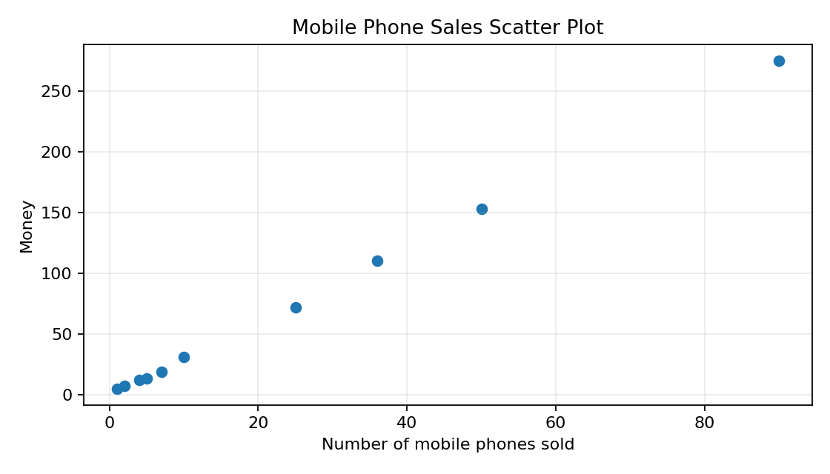
Observation: The points show a strong positive relationship: larger numbers of phones sold generally correspond to larger money values.

Experiment 6: FP-Growth Association Rules
Aim: Generate association rules using FP-Growth with minimum support 50% and confidence 75%, as specified in the source. fileciteturn1file0L147-L147
Procedure: Prepare the transaction data supplied by the instructor, load it into an association-rule format, select FP-Growth in WEKA, set minimum support to 0.50 and minimum metric/confidence to 0.75, then run the algorithm.
Important: The transaction table required for this experiment is not present in the supplied document text, so specific frequent itemsets and rules cannot be calculated faithfully from the source.
Result: Run FP-Growth with support = 50% and confidence = 75% and record the generated rules from the actual dataset.

Experiment 7: Diabetes Classification – Decision Tree vs SVM
Aim: Predict diabetes data using a Decision Tree classifier in WEKA, compare it with SVM, calculate accuracy and F1 measure, plot the graph and explain the summary. fileciteturn1file0L151-L151
- Load the diabetes dataset into WEKA.
- Select the diabetes outcome as the class attribute.
- Run a Decision Tree classifier such as J48.
- Record the confusion matrix and summary.
- Run SVM/SMO on the same training/test setup.
- Compare accuracy, precision, recall and F1.
Accuracy formula: Accuracy = (TP + TN) / (TP + TN + FP + FN) × 100.
F1 formula: F1 = 2 × Precision × Recall / (Precision + Recall).
Metric | Decision Tree | SVM
Accuracy | Record WEKA value | Record WEKA value
F1 | Calculate from WEKA precision/recall | Calculate from WEKA precision/recall
Figure 7.1 – Illustrative comparison; replace with actual WEKA result graph
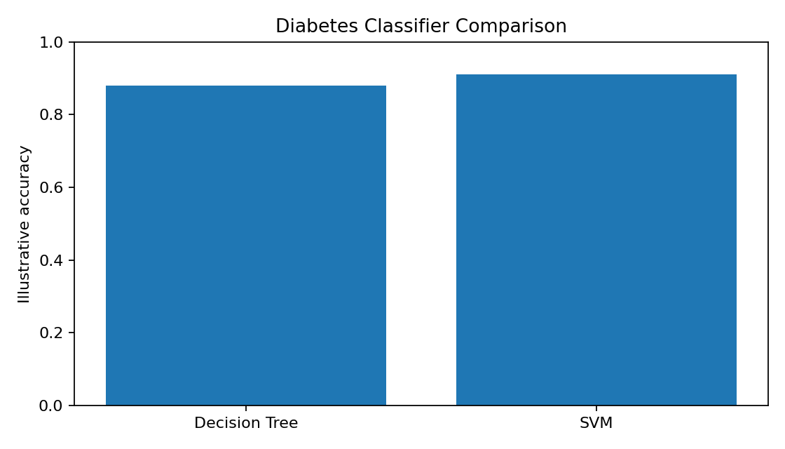
Result: The source does not provide actual diabetes classifier output, so the graph above is only an illustrative placeholder. Final accuracy/F1 must be copied from the WEKA run.

Experiment 8: Data Binning and Histogram
Aim: Partition the 17 marks into three bins using equal-frequency, equal-width and clustering methods, and plot a histogram. fileciteturn1file0L156-L159
Sorted data: 50, 55, 55, 55, 58, 59, 60, 61, 63, 63, 65, 65, 67, 71, 71, 72, 75
Equi-depth bins (approximately equal number of observations):
Bin | Values
Bin 1 | 50, 55, 55, 55, 58, 59
Bin 2 | 60, 61, 63, 63, 65, 65
Bin 3 | 67, 71, 71, 72, 75
Equal-width interval width = (75−50)/3 = 8.33. Intervals can be reported as [50,58.33), [58.33,66.67), [66.67,75].
Figure 8.1 – Histogram
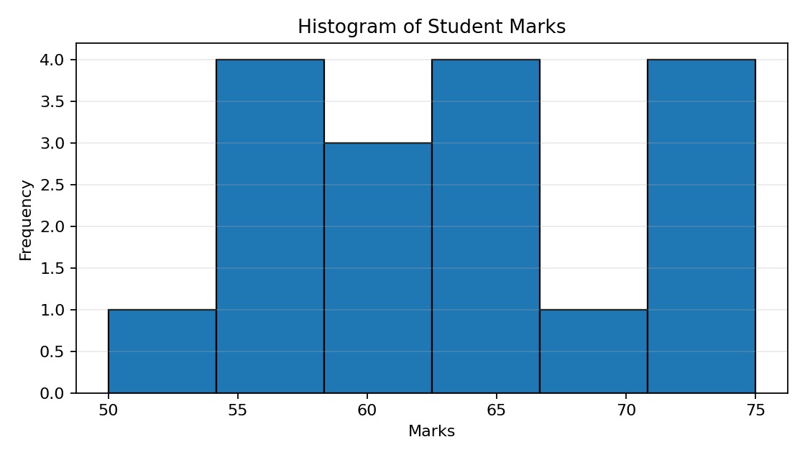
Clustering: Apply a one-dimensional clustering method such as K-Means with k=3. The exact cluster membership should be recorded from the software run.

Experiment 9: Decision Tree and Rule-Based Induction
Aim: Create the dataset represented by the given decision tree in ARFF format, calculate accuracy and decisions, generate rules by rule-based induction, compare algorithms and plot a confusion matrix. fileciteturn1file0L161-L164
ARFF template:
@relation decision_tree_data
@attribute attribute1 {yes,no}
@attribute attribute2 {yes,no}
@attribute class {yes,no}
@data
yes,yes,yes
yes,no,no
no,yes,no
no,no,no
The actual decision-tree diagram referenced by the exercise is not included in the extracted source content. Therefore, the template above is illustrative and should be replaced by the attributes/branches from the actual diagram.
Accuracy is calculated from the confusion matrix using (TP+TN)/total × 100.
Figure 9.1 – Illustrative confusion matrix
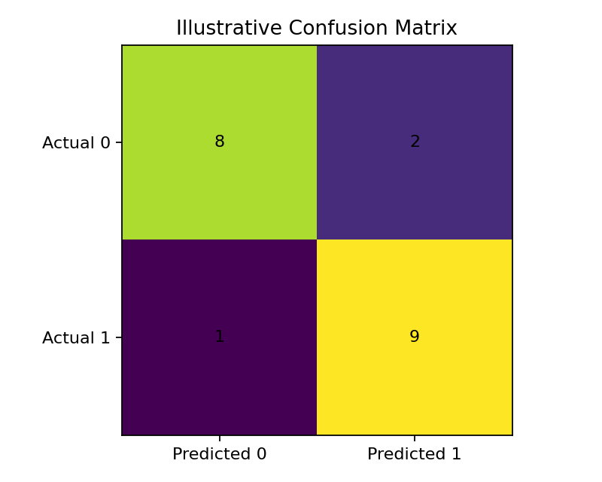
Result: The actual accuracy, rules and confusion matrix must be generated from the supplied decision-tree diagram/data; the source text alone does not contain enough information to determine them.

Experiment 10: Apriori vs FP-Growth
Aim: Create an ARFF file and implement Apriori and FP-Growth, compare generated rules, and identify unique rules. Minimum support = 2 transactions and confidence = 50%. fileciteturn1file0L166-L197
T.ID | Items
T1 | SONY, BPL, LG
T2 | BPL, SAMSUNG
T3 | BPL, ONIDA
T4 | SONY, BPL, SAMSUNG
T5 | SONY, ONIDA
T6 | BPL, ONIDA
T7 | SONY, ONIDA
T8 | SONY, BPL, ONIDA, LG
T9 | SONY, BPL, ONIDA
ARFF approach: Represent each item as a Boolean attribute (SONY, BPL, LG, SAMSUNG, ONIDA) and encode each transaction as true/false values.
Frequent itemset |  | Support count
{BPL} |  | 7
{LG} |  | 2
{ONIDA} |  | 6
{SAMSUNG} |  | 2
{SONY} |  | 6
{BPL, LG} |  | 2
{BPL, ONIDA} |  | 4
{BPL, SAMSUNG} |  | 2
{BPL, SONY} |  | 4
{LG, SONY} |  | 2
{ONIDA, SONY} |  | 4
{BPL, LG, SONY} |  | 2
{BPL, ONIDA, SONY} |  | 2
Rule | Support count |  | Confidence
{LG} → {BPL} | 2 |  | 100.0
{BPL} → {ONIDA} | 4 |  | 57.14
{ONIDA} → {BPL} | 4 |  | 66.67
{SAMSUNG} → {BPL} | 2 |  | 100.0
{BPL} → {SONY} | 4 |  | 57.14
{SONY} → {BPL} | 4 |  | 66.67
{LG} → {SONY} | 2 |  | 100.0
{ONIDA} → {SONY} | 4 |  | 66.67
{SONY} → {ONIDA} | 4 |  | 66.67
{LG} → {BPL,SONY} | 2 |  | 100.0
{BPL,LG} → {SONY} | 2 |  | 100.0
{BPL,SONY} → {LG} | 2 |  | 50.0
{LG,SONY} → {BPL} | 2 |  | 100.0
{BPL,ONIDA} → {SONY} | 2 |  | 50.0
{BPL,SONY} → {ONIDA} | 2 |  | 50.0
{ONIDA,SONY} → {BPL} | 2 |  | 50.0
Comparison: Apriori generates candidate itemsets level by level and tests support repeatedly. FP-Growth compresses transactions into an FP-tree and mines frequent patterns without the same candidate-generation process. With the same thresholds, the algorithms should identify the same frequent patterns, although their mining processes differ.
Result: The frequent itemsets and qualifying rules above are computed from the supplied nine transactions. Actual WEKA rule ordering/count of displayed rules may vary with configuration.

Experiment 11: Normalization of Strike Rates
Aim: Normalize the strike rates 100, 70, 60, 90, 90 using min-max, z-score, z-score with mean absolute deviation, and decimal scaling. fileciteturn1file0L212-L216
Value | Min-Max | Z-score | Z-score (MAD) | Decimal scaling
100.0 | 1.0 | 1.2247 | 1.3235 | 1.0
70.0 | 0.25 | -0.8165 | -0.8824 | 0.7
60.0 | 0.0 | -1.4969 | -1.6176 | 0.6
90.0 | 0.75 | 0.5443 | 0.5882 | 0.9
90.0 | 0.75 | 0.5443 | 0.5882 | 0.9
Mean = 82.00; population standard deviation = 14.70; mean absolute deviation = 13.60.
Result: Min-max maps the minimum to 0 and maximum to 1. Z-score centers values around zero. MAD-based normalization uses the mean absolute deviation instead of standard deviation. Decimal scaling divides by 10^j until the maximum absolute value is below 1.

Experiment 12: Standard Deviation and Variance
Aim: Calculate standard deviation and variance for AvgSpeed and TotalTime. The source gives nine observations for each variable. fileciteturn1file0L218-L245
Car | AvgSpeed (kph) | TotalTime (min)
1 | 78 | 39
2 | 81 | 37
3 | 82 | 36
4 | 74 | 42
5 | 83 | 35
6 | 82 | 36
7 | 77 | 40
8 | 80 | 38
9 | 70 | 46
AvgSpeed: mean = 78.5556; population variance = 16.4691; population standard deviation = 4.0582; sample variance = 18.5278; sample standard deviation = 4.3044.
TotalTime: mean = 38.7778; population variance = 10.8395; population standard deviation = 3.2923; sample variance = 12.1944; sample standard deviation = 3.4921.
Result: If the laboratory expects sample statistics, use the sample variance/standard deviation; if the nine values are treated as the complete population, use the population values.

Experiment 13: Apriori and FP-Growth Frequent Itemsets and Strong Rules
Aim: Find frequent itemsets using Apriori and FP-Growth, compare efficiency, and list strong association rules matching the specified metarule. The source supplies five transactions. fileciteturn1file0L248-L257
TID | Items
T100 | M, O, N, K, E, Y
T200 | D, O, N, K, E, Y
T300 | M, A, K, E
T400 | M, U, C, K, Y
T500 | C, O, K, I, E
Support threshold: The source text for Experiment 13 does not explicitly state a minimum support/confidence threshold. Therefore, a unique final set of 'strong' rules cannot be determined without the missing thresholds.
Itemset | Support count | Support %
{C} | 2 | 40%
{E} | 4 | 80%
{K} | 5 | 100%
{M} | 3 | 60%
{N} | 2 | 40%
{O} | 3 | 60%
{Y} | 3 | 60%
{C,K} | 2 | 40%
{E,K} | 4 | 80%
{E,M} | 2 | 40%
{E,N} | 2 | 40%
{E,O} | 3 | 60%
{E,Y} | 2 | 40%
{K,M} | 3 | 60%
{K,N} | 2 | 40%
{K,O} | 3 | 60%
{K,Y} | 3 | 60%
{M,Y} | 2 | 40%
{N,O} | 2 | 40%
{N,Y} | 2 | 40%
{O,Y} | 2 | 40%
{E,K,M} | 2 | 40%
{E,K,N} | 2 | 40%
{E,K,O} | 3 | 60%
{E,K,Y} | 2 | 40%
{E,N,O} | 2 | 40%
{E,N,Y} | 2 | 40%
{E,O,Y} | 2 | 40%
{K,M,Y} | 2 | 40%
{K,N,O} | 2 | 40%
{K,N,Y} | 2 | 40%
{K,O,Y} | 2 | 40%
{N,O,Y} | 2 | 40%
Efficiency comparison: Apriori repeatedly generates candidate itemsets and scans/tests support. FP-Growth builds a compact FP-tree and mines frequent patterns through conditional pattern bases. For larger datasets, FP-Growth generally avoids the candidate-generation overhead of Apriori.
Metarule interpretation: X buys item1 AND item2 ⇒ X buys item3. To list only strong rules, specify the required minimum support and confidence, then test every two-item antecedent and one-item consequent against the transaction database.
Result: Frequent itemsets with support count at least 2 are listed above. Exact strong rules require the missing support/confidence thresholds.

Overall Conclusion
The Day 4 exercise sheet covers clustering, classification, association-rule mining, visualization, data preprocessing/normalization, descriptive statistics and rule-based induction. This document organizes all 13 tasks into a practical laboratory-record format with aims, procedures, calculations, results and illustrative figures. Where the original sheet omits required input data or actual software output, that limitation is explicitly identified rather than inventing a result.
Source: uploaded Day 4 Exercises document. fileciteturn1file0L40-L42

